|| Jai Meena 2 ||

Written by : Renuka Muddamshetty, Student of Poorva Bhadra Batch JKR Astro Research Foundation

PSA principle 31 - **Shani is lord of death & whose deity is yama, in case of death, Shani will always be connected with relevant houses or its lord**

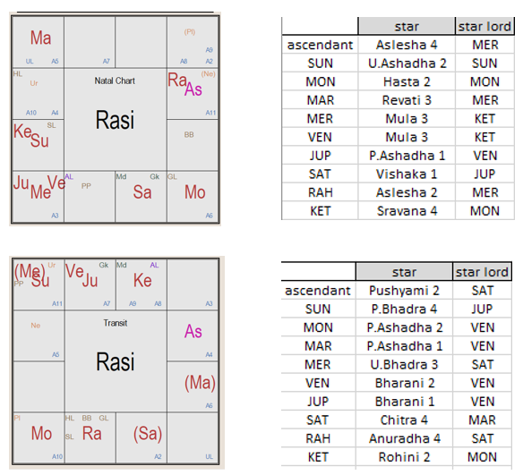

The native is of cancer lagna and Virgo moon sign.

Venus is badhaka for him ,whereas sun being lord of 2nd and Shani being lord of 7th are marakas.

He passed away on during ketu dasa and Jupiter bhukti.

**why Ketu Dasa delivers the result?**

In the natal chart, the dasa lord Ketu is placed in 7th house which is maraka house , it is with maraka sun there and both aspect the lagna.

Badhakesh Venus too is in ketu star

Ketu is in lagnesh moon ‘s star sravana nakshatra. This moon is paced in 3rd house (8th from 8th ) and is aspected by mars which is lord of 10th house, hence it gives ketu digbala .

Shani the 8th lord and ayush karaka in natal chart is in star of Jupiter - vishaka 1 and has forward binna pada connect to 5th house, so from 5th house it has its 3rd aspect on ketu.

**why jupiter bhukti delivers the result?**

In natal chart, Jupiter is lord of 6th house (roga) in its own sign ,star of badhaka venus ,with badhakadhipati venus and 12th lord mercury .All are aspected by 8th lord & ayush karaka shani via 3rd aspect of Shani.

Since Shani placed in 4th house & aspects Venus , badhaka venus gets digbala

Hence Jupiter being in its own sign and its star lord having digbala becomes strong and a candidate to give result too.

Shani lord of 8th house is in vishaka whose star lord is rogadhipati Jupiter again.

*{Note:- Shani is exalted in natal chart , so it’s a very strong 8th lord ayush karak shani that aspects both the dasanath ketu and bhukti natha Jupiter in natal chart}*

**Analyzing transit chart**

In transit chart, shani is retro and again exalted in libra on the day of event .

It aspects the 6th lord Jupiter and badhaka venus via 7th aspect , lagna via 10th aspect & lagnesh moon via 3rd aspect , while itself is in sign owned by badhaka venus and aspected by badhaka venus and rogadhipati Jupiter too.

Here moon which is placed is 6th house in transit chart & is aspected also by 6th lord Jupiter too.

lagnesh moon in transit is p.ashada whose star lord is badhaka venus, which is with rogadhipati Jupiter and aspected by 8th lord shani.

This moon is the star lord of dasanatha ketu in transit chart . Also Dasanath ketu is in badhaka sthan in transit chart.

Saturn in transit chart is again getting connected to dasanatha ketu and bhuktinatha jupiter

**Analyzing the 8th lords and its connections**

shani the 8th lord in transit chart is in star of mars chitta, this mars is in p.ashadha i.e badhaka venus star and placed in 2nd house , which is maraka house and aspects the 7th and 8th house of native from there ,it also aspects Rahu via 4th aspect .

Rahu is also the co-lord of kumbha as per meena 2, i.e hence its the 8th co lord along with Shani

In natal chart , Rahu co-lord of 8th house is in lagna and in star of 12th lord mercury and aspected by mararka sun , Aspected by maraka and ayush karaka exalted shani further Star lord of rahu which is mercury is also aspected by exalted shani and since shani is lord of 7th house ,rahu gets digbala too .

Whereas in transit chart Rahu is placed in scorpio in 5th house in anuradha star ,which is star of shani

Shani being in chitta 4 padam has backward binna pada connect to 3rd house (which is 8th from 8th hence also taken as secondary house longevity) and from there it aspects the co-lord of 8th house rahu via 3rd aspect , maraka sun and 12th lord mercury via 7th aspect & dasanatha ketu via 10th aspect

So in addition to 6,8,12 lagna,lagnesh badhakesh marakesh all getting connected ,

shani not only gets connected to dasanatha bhuktinatha but also to the 8th house and its lords both in natal as well as the transit chart on the day of event as per the PSA principle 31

--------------------------------------------------------------- x -------------------------------------------------------------------------